**CSCE 5612 – Embedded Hardware**

**Lab-10**

**Name: Manasa Varala**

**Student Id: 11727461**

**Video-1:**

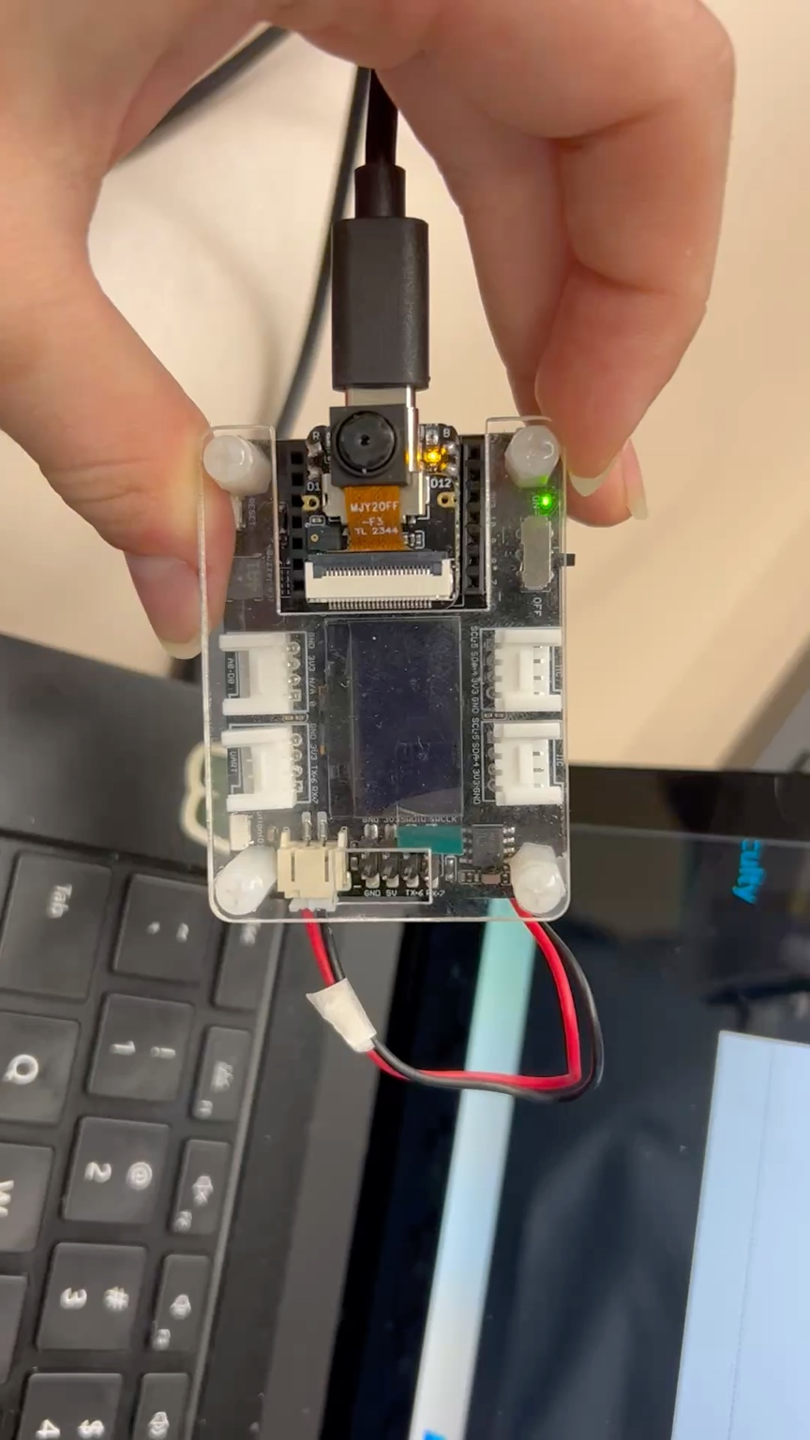

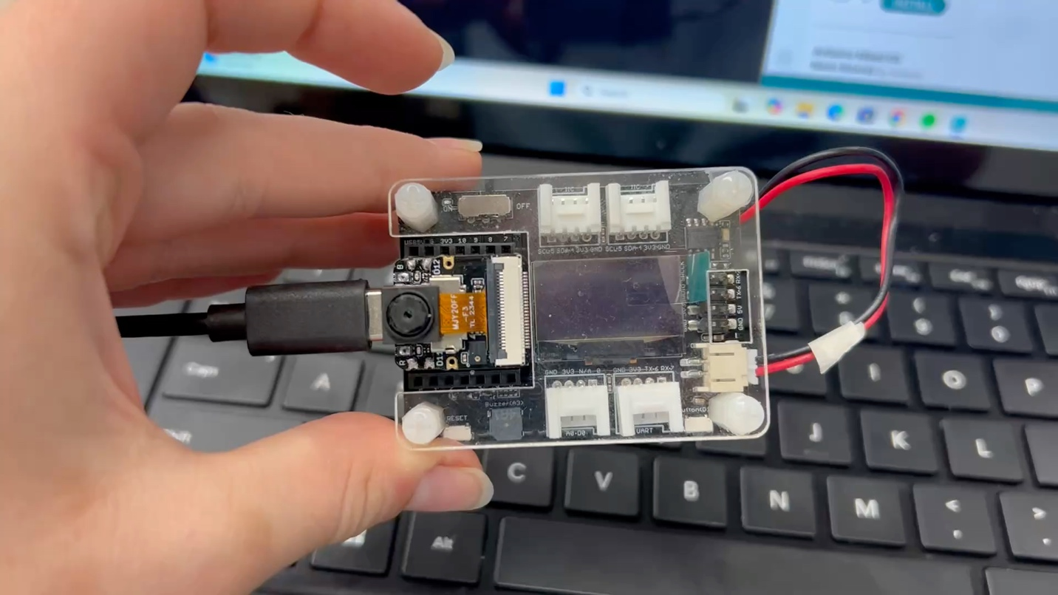**Video-1-2:**

**Image-2:**

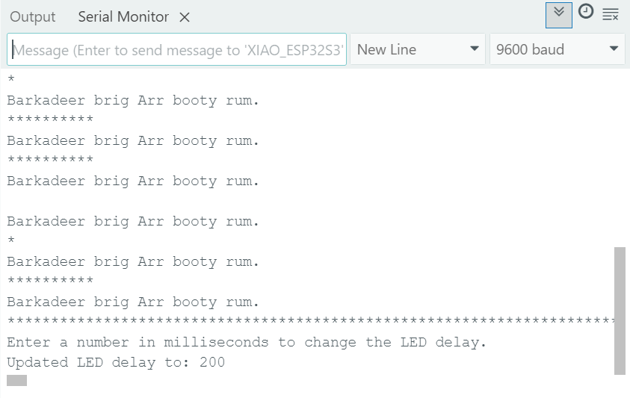

**Image2-2:**

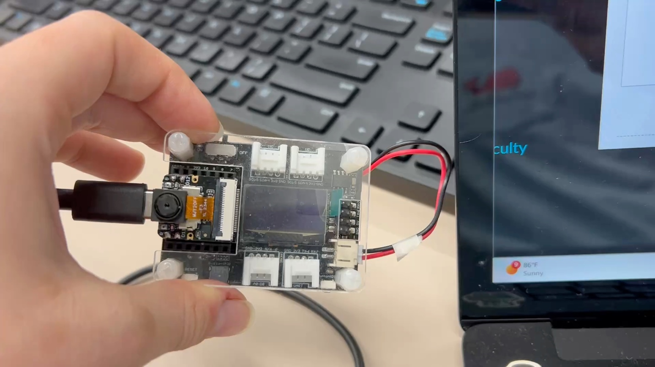**Video-2:**

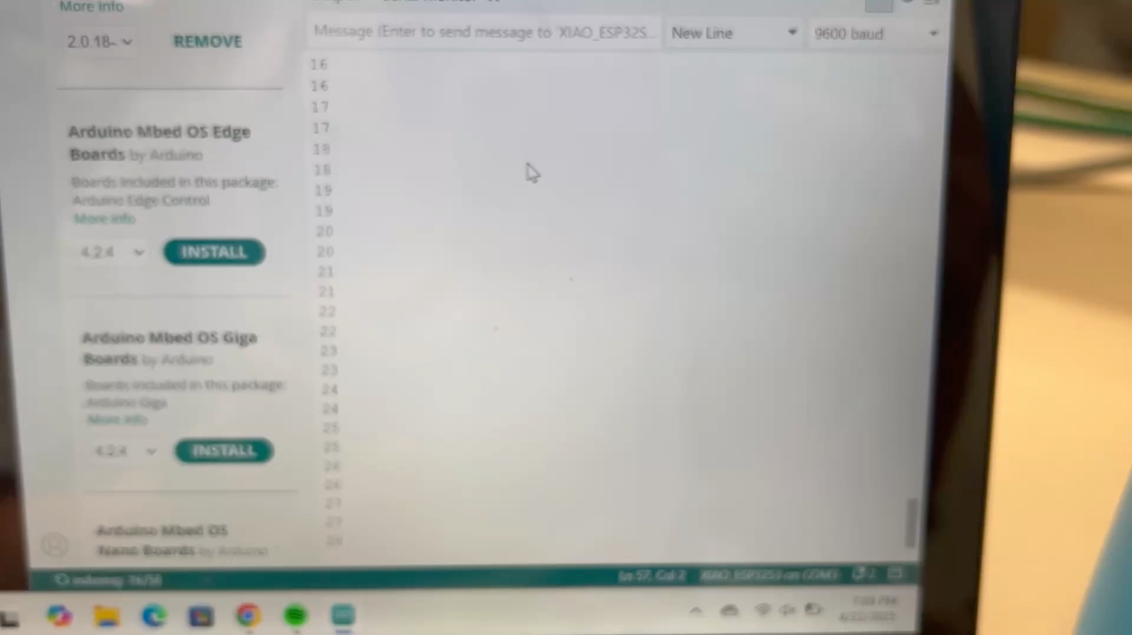**Image-3:**

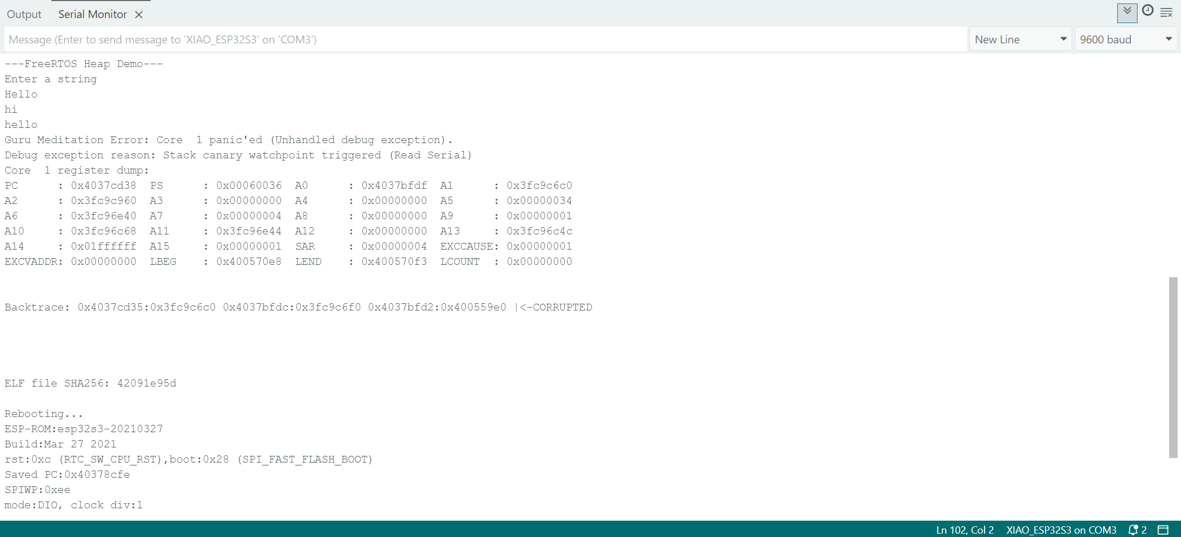

**Video-4:**

**Image-5:**

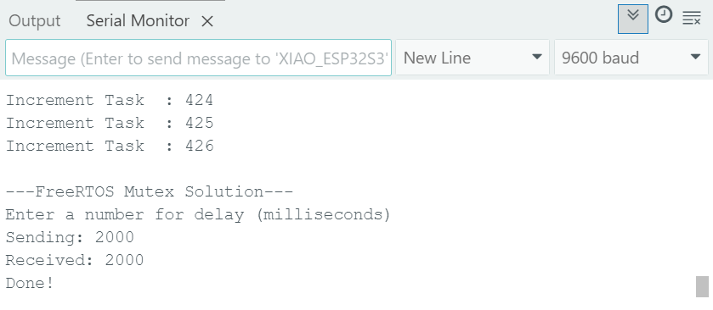

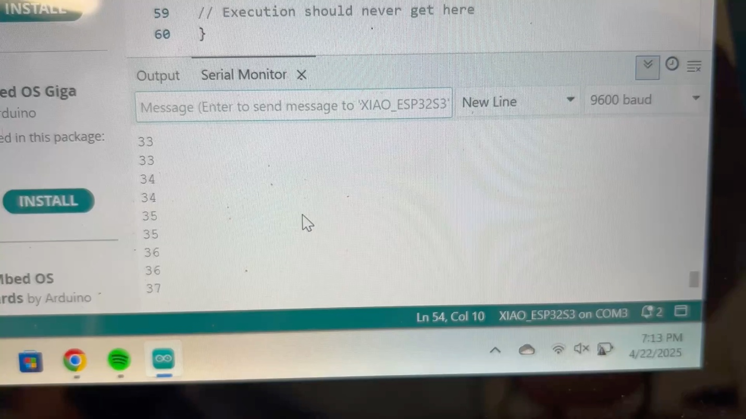**Video-5:**

**Video-5-2:**

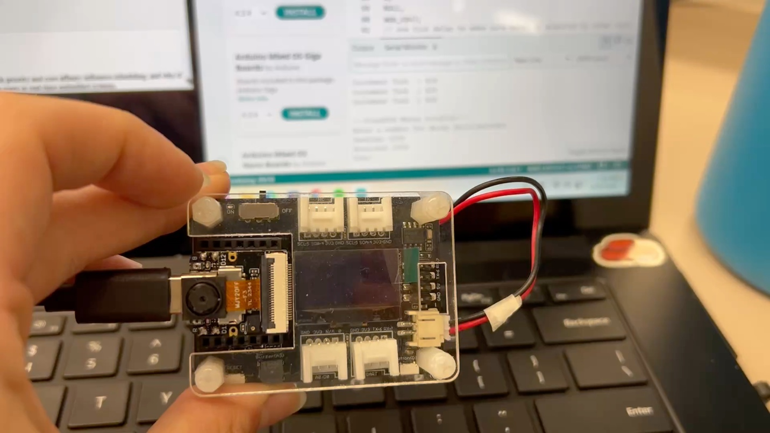**Video-5-3:**

**Image-6:**

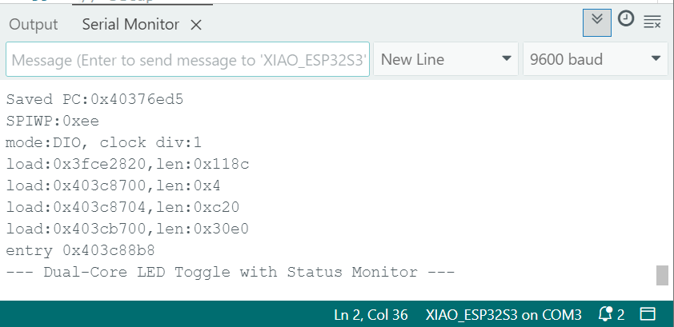

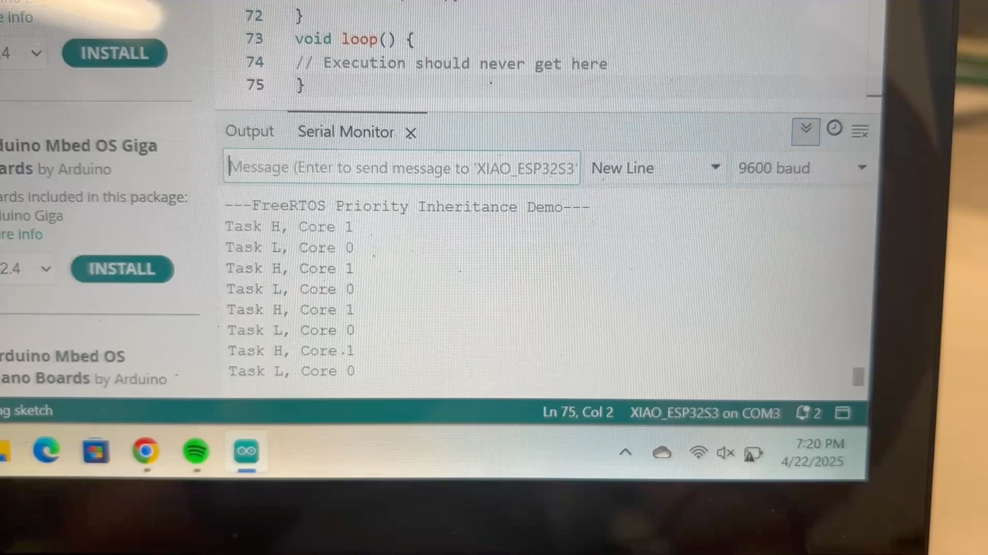**Video-6:**

**Video-6-2:**

**Image-7:**

